1. Explore restaurants

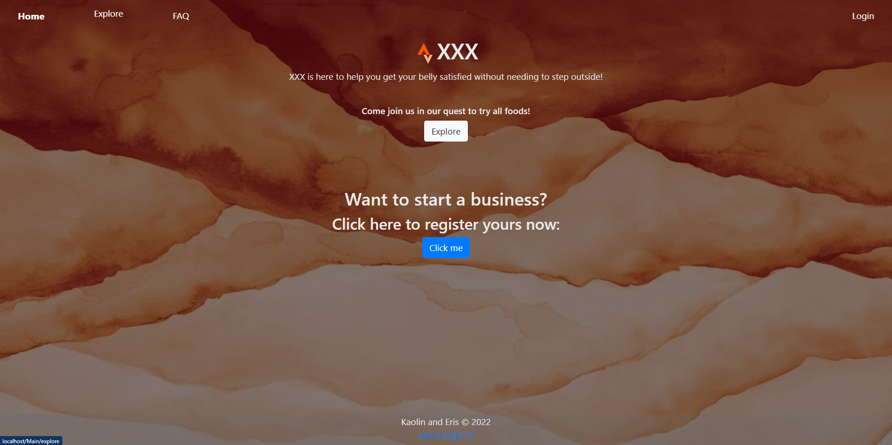

Step 1. On the top left of the home page, click the explore button to check out restaurants.

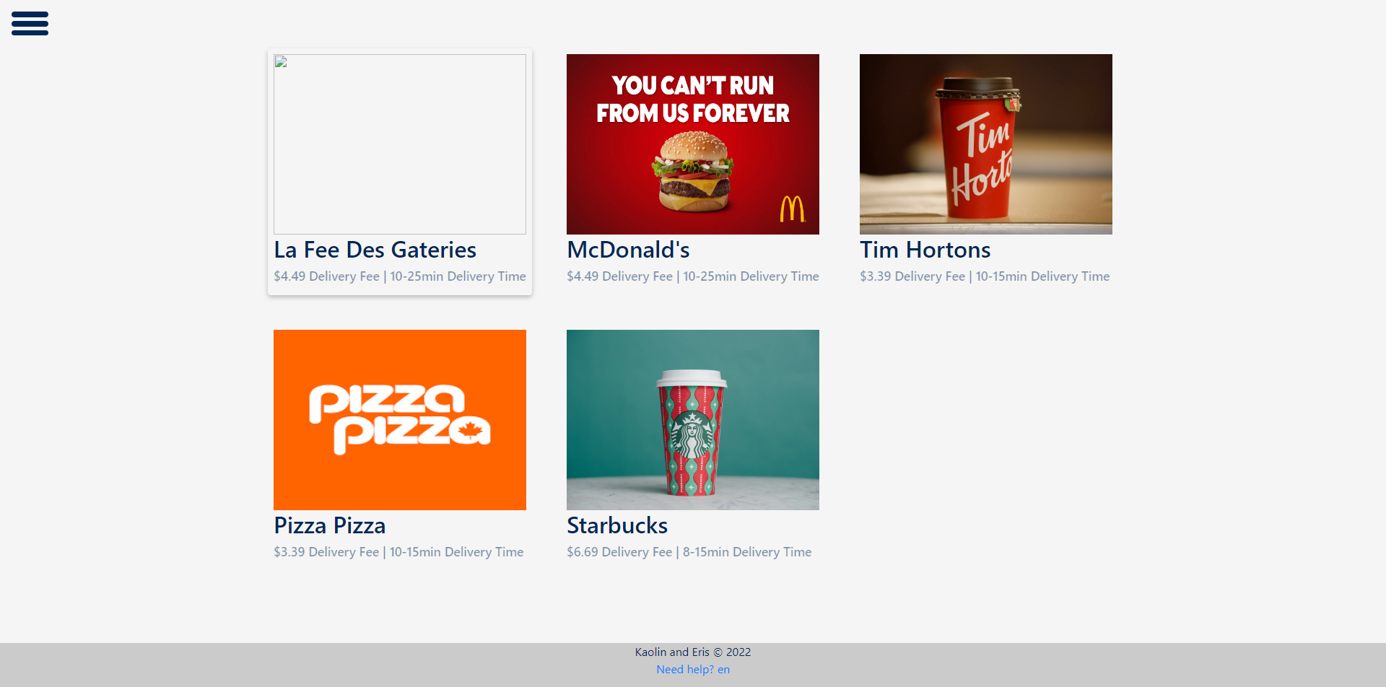

Step 2. Scroll through available restaurants

1. Register

Step 1. Click the hamburger menu on the top left of the explore page

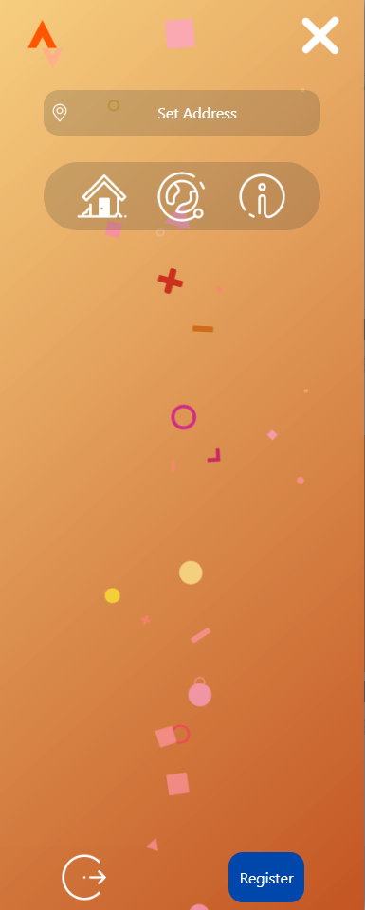

Step 2. Click the register button situated at the bottom right of the side menu

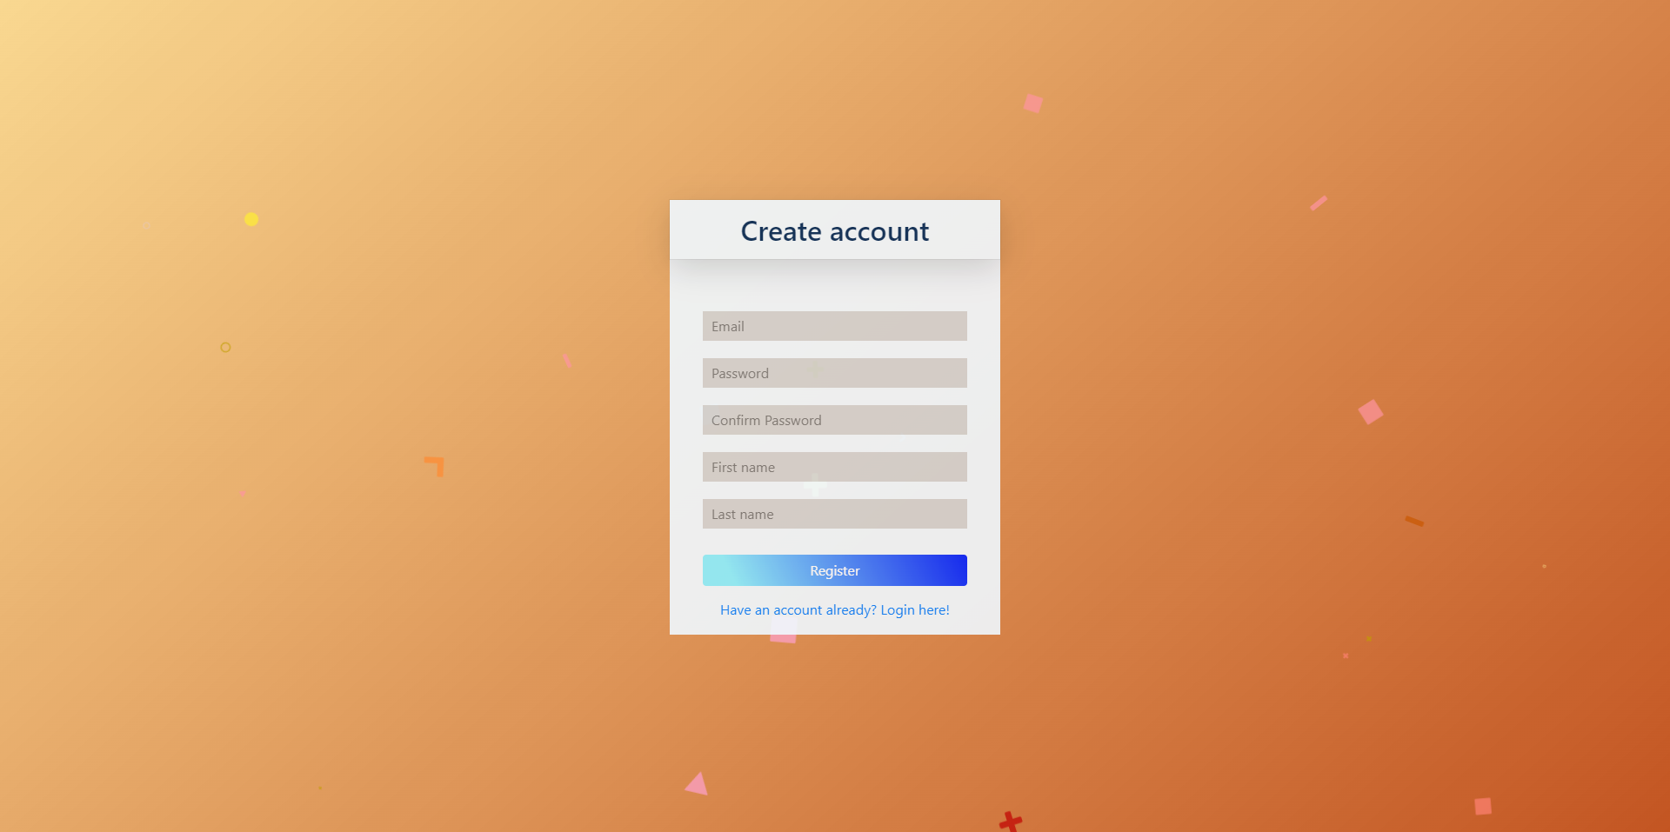

Step 3. Enter your information

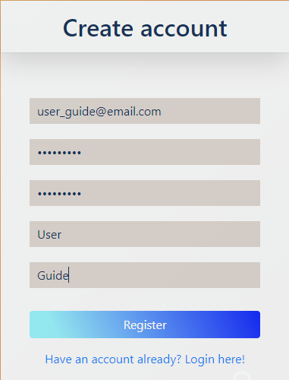

Step 4. Click register

1. Login

Step 1. Click the hamburger menu on the top left of the explore page



Step 2. Click the login button situated at the bottom left of the side menu

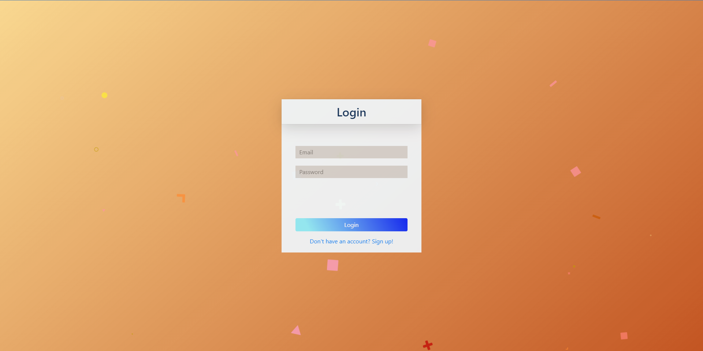

Step 3. Enter your credentials and login

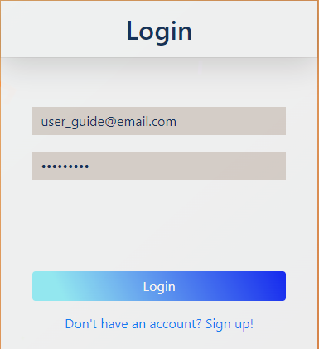

Step 4. You are now logged in with the option to logout on the top right of the main page.

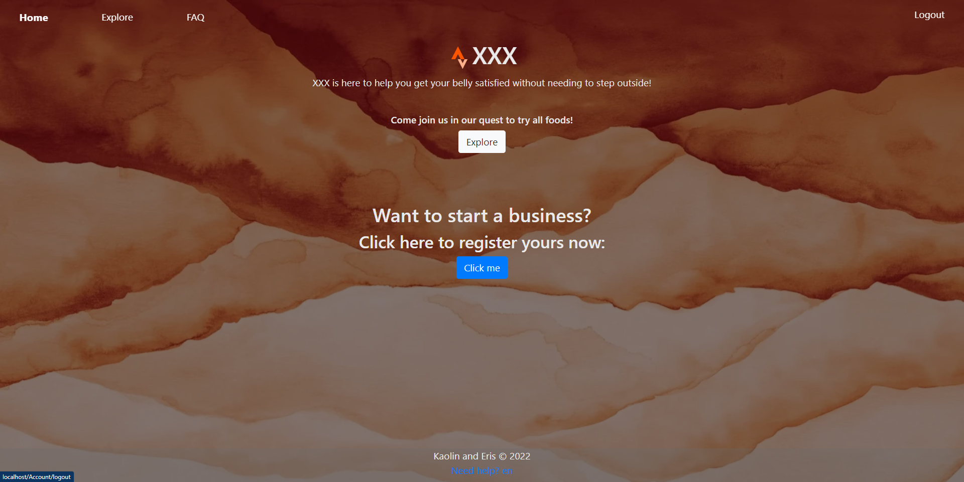

1. Set your delivery address

Step 1. Click the hamburger menu on the top left of the explore page



Step 2. Click the set address button on the top of the side menu

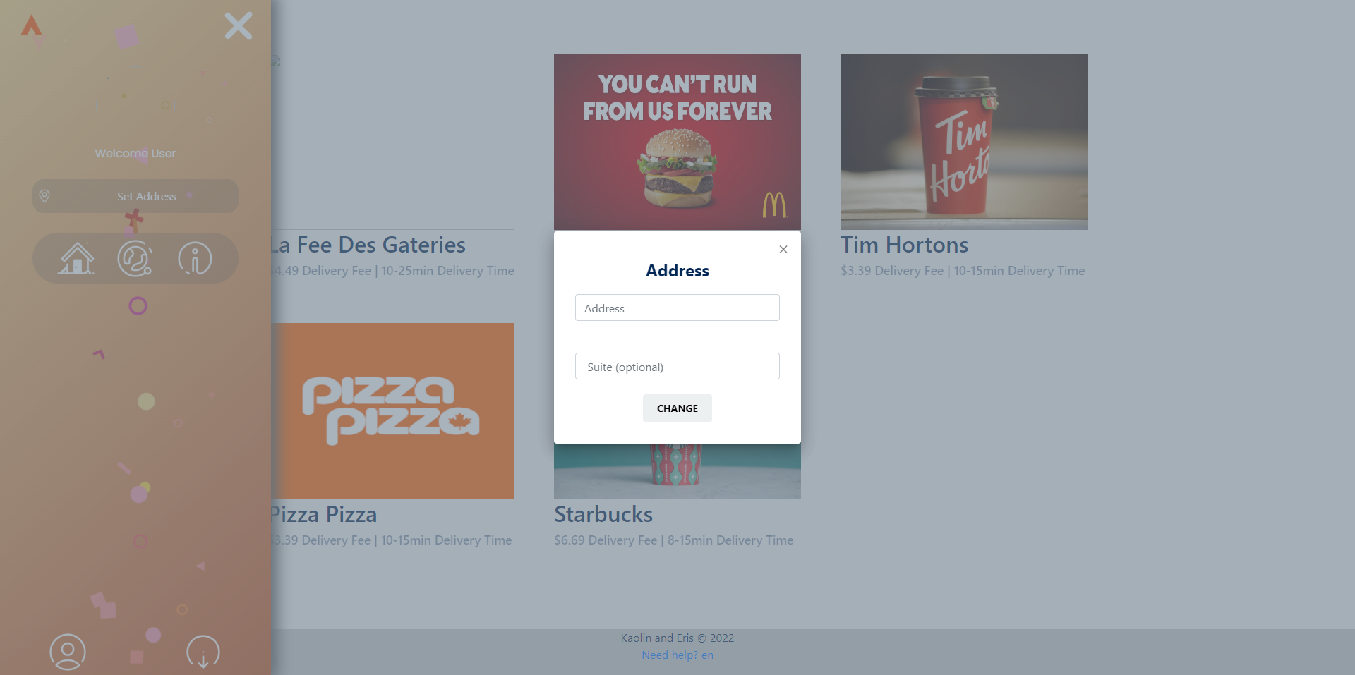

Step 3. Enter your address and click change

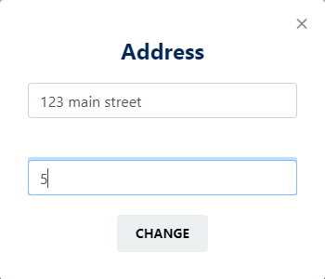

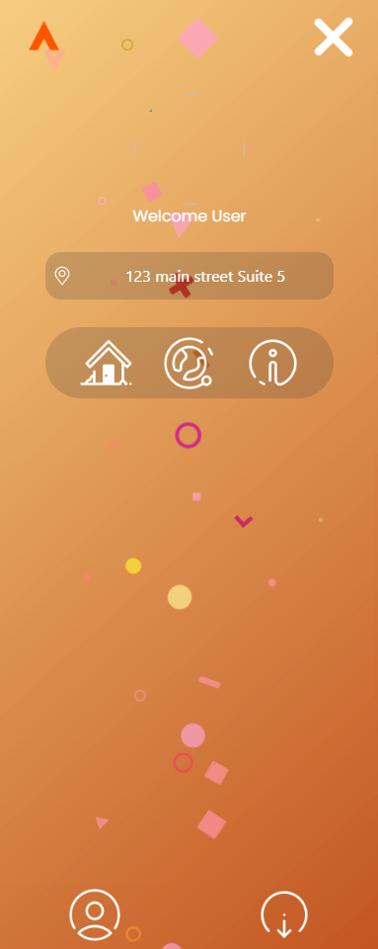

1. Start an order for a restaurant

Step 1. Go to the explore page



Step 2. Pick a restaurant from the options

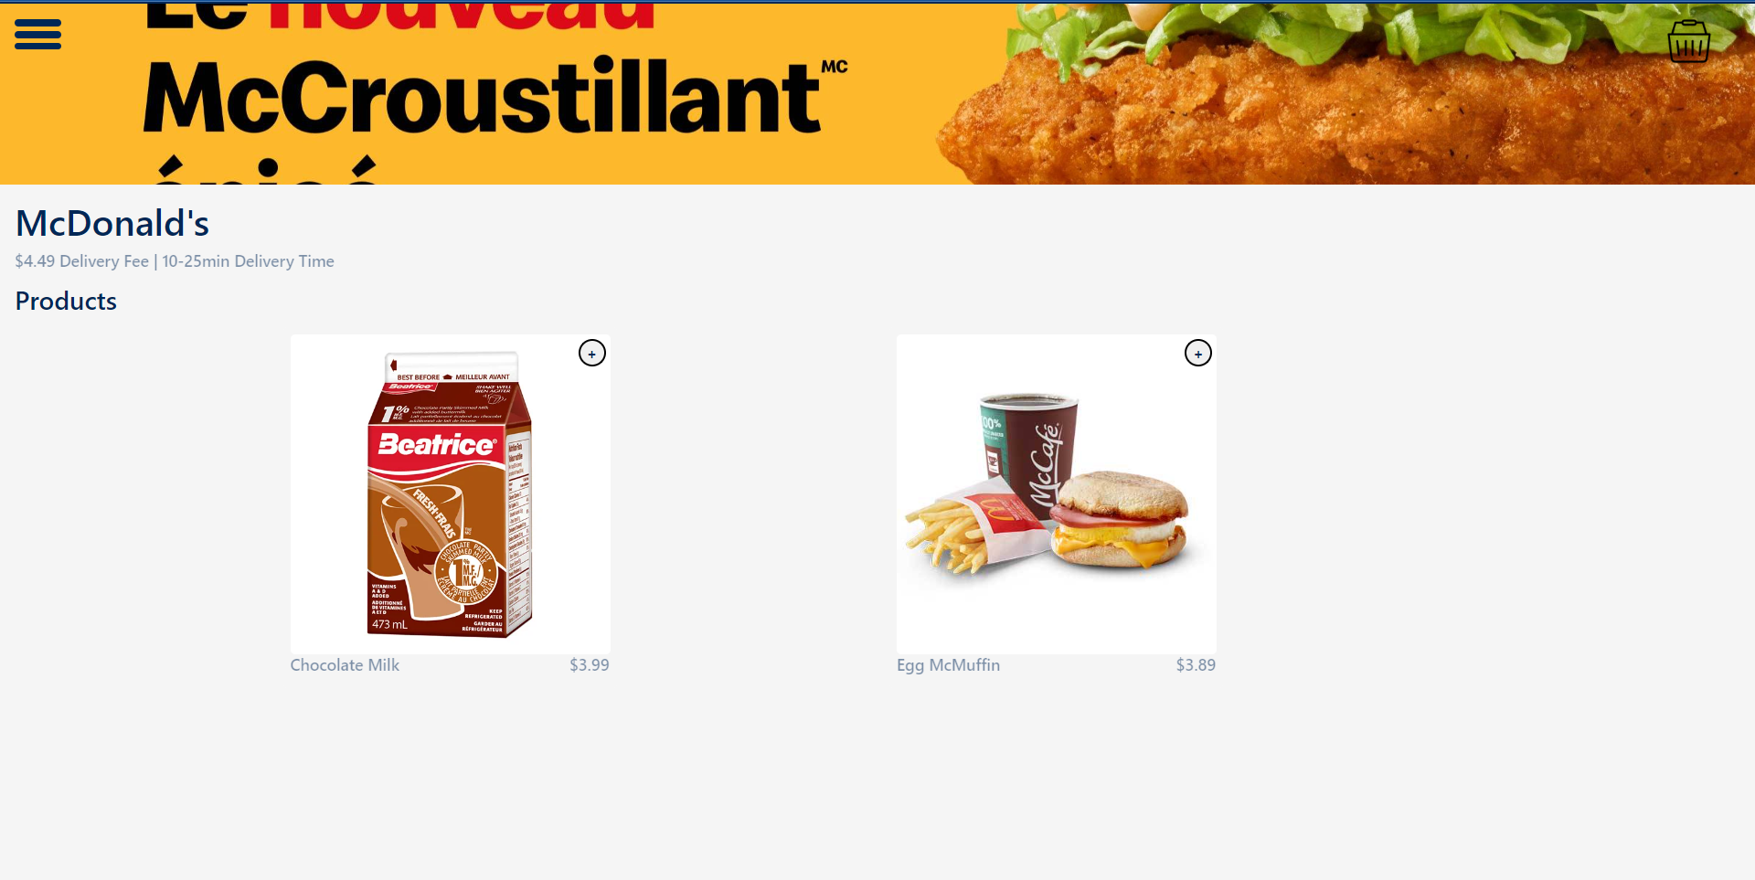

Step 3. Pick your items

1. View your checkout

Step 1. On any page except the home page, click on the basket button on the top right of the page (this button only appears when you have started placing an order)

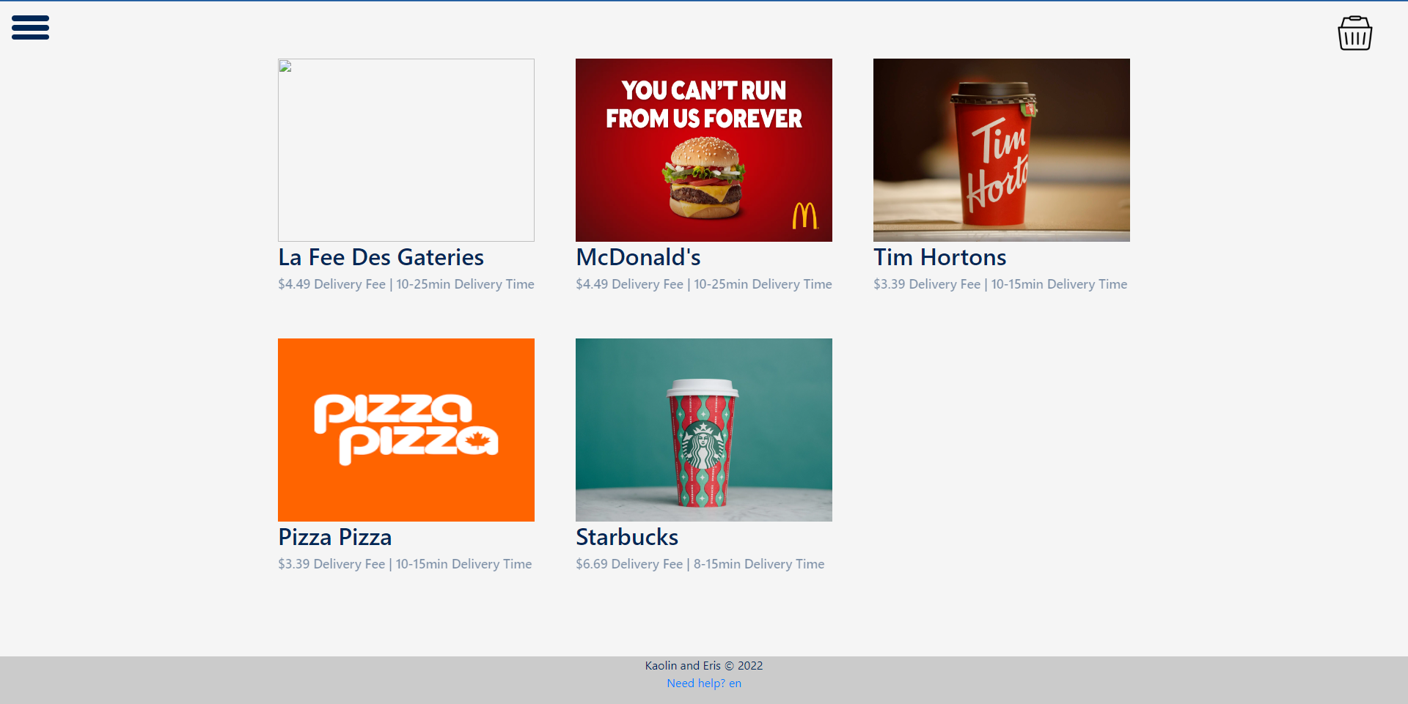

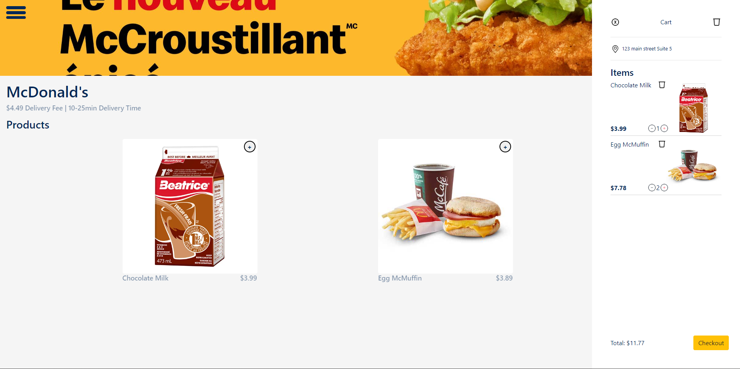

1. Understanding the cart menu (total of 8 features in this menu)

Step 1. Open your cart menu



Actions:

-Click the x button on the top left to close the menu (this will not clear the cart)

-Click the bin on the top right to clear your cart

-Verify your address on the second line

-Verify your products along with their price and quantity

-Click the bin on the right of a product to remove it from your cart

-Click the + or – buttons to adjust the quantity of a certain product (if at 1, you click minus, it will prompt you to remove the product entirely)

-Take a look at the total price on the bottom left of the menu

-Click the checkout button to finalise and place the order

1. Trying to order from another restaurant at the same time

* To prevent any issues for delivery drivers, you can only place an order with one restaurant per receipt. Trying to access another restaurant will prompt you to restart your order or continue where you left off before.

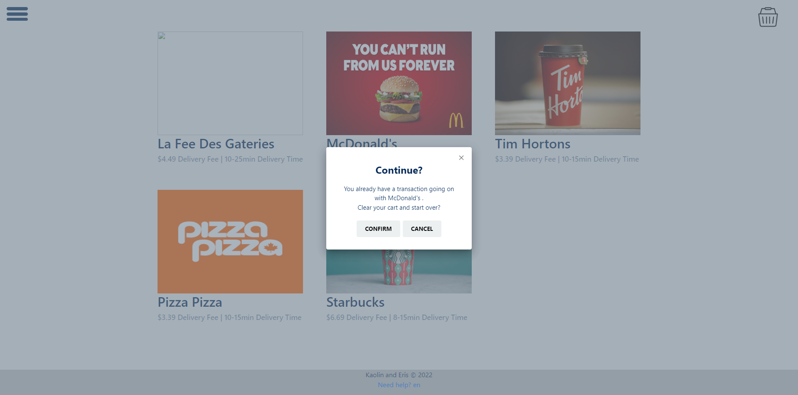

1. Checking out

Step 1. Open the cart menu



Step 2. Click the checkout button on the bottom right

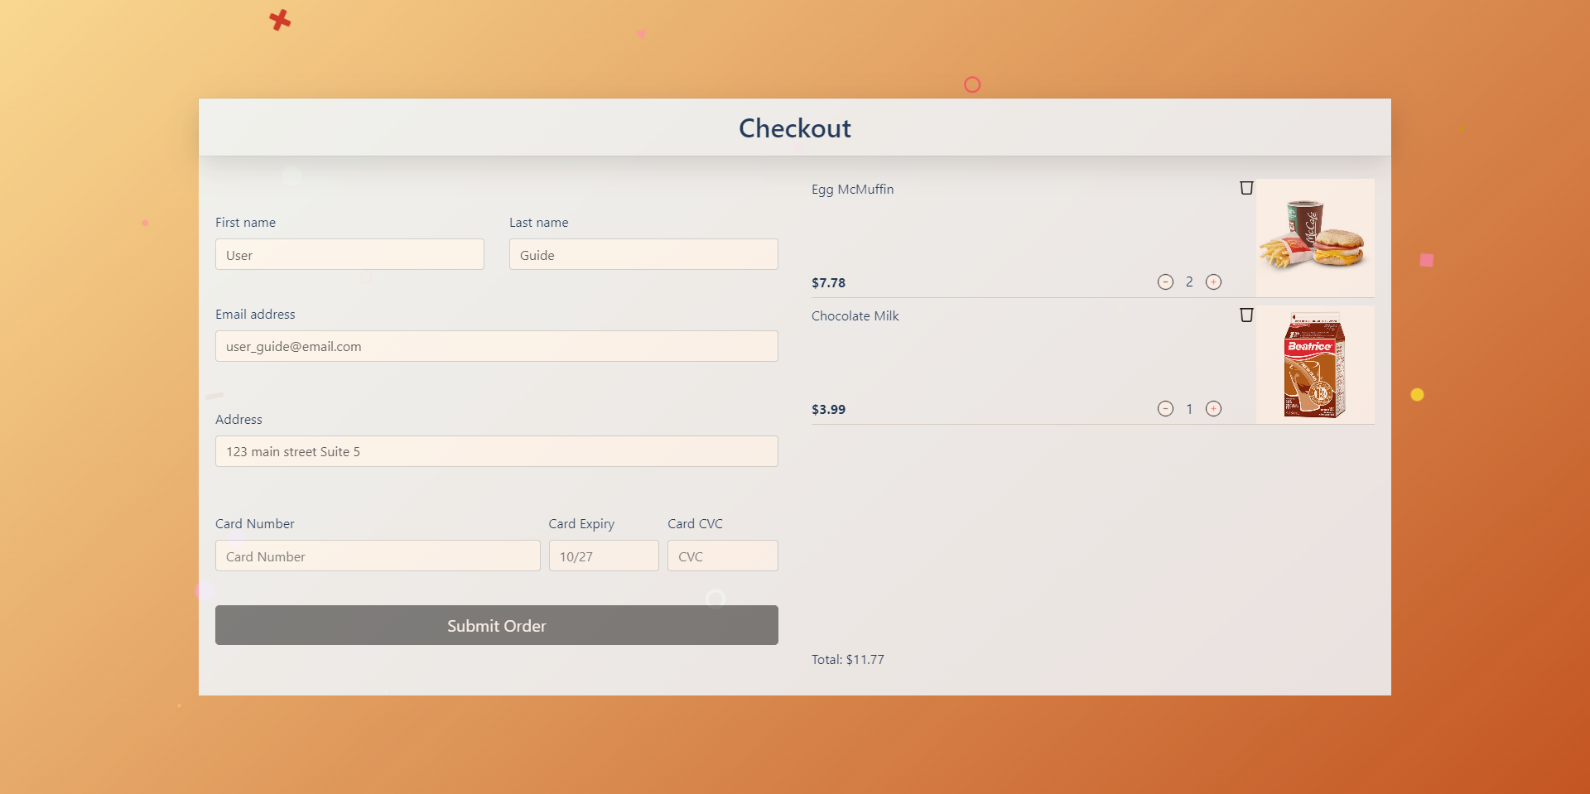

Step 3. Adjust any information in the form as well as adjust the products if need be (when logged in, your information is input automatically though you can still adjust it)

Step 4. Input your card details to pay and click submit order

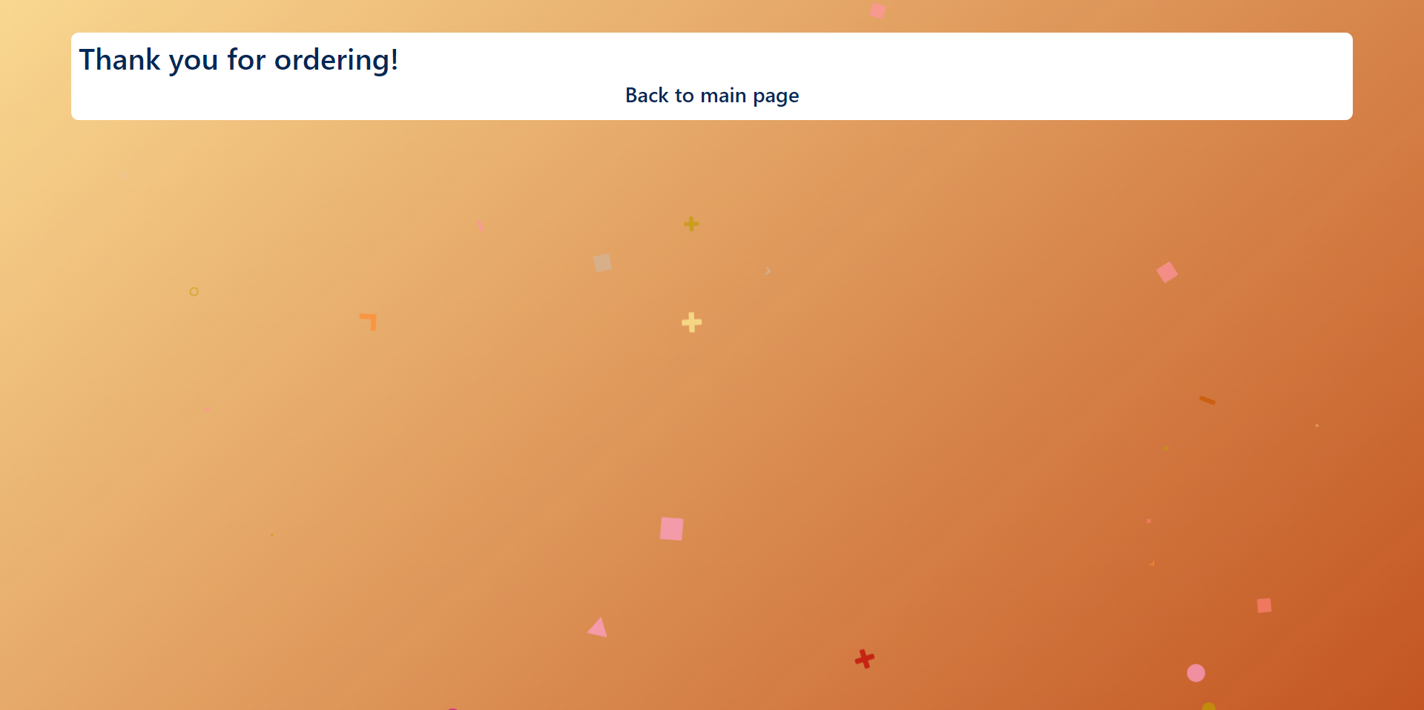

1. Placing an order without being logged in

Step 1. Head over to the explore page

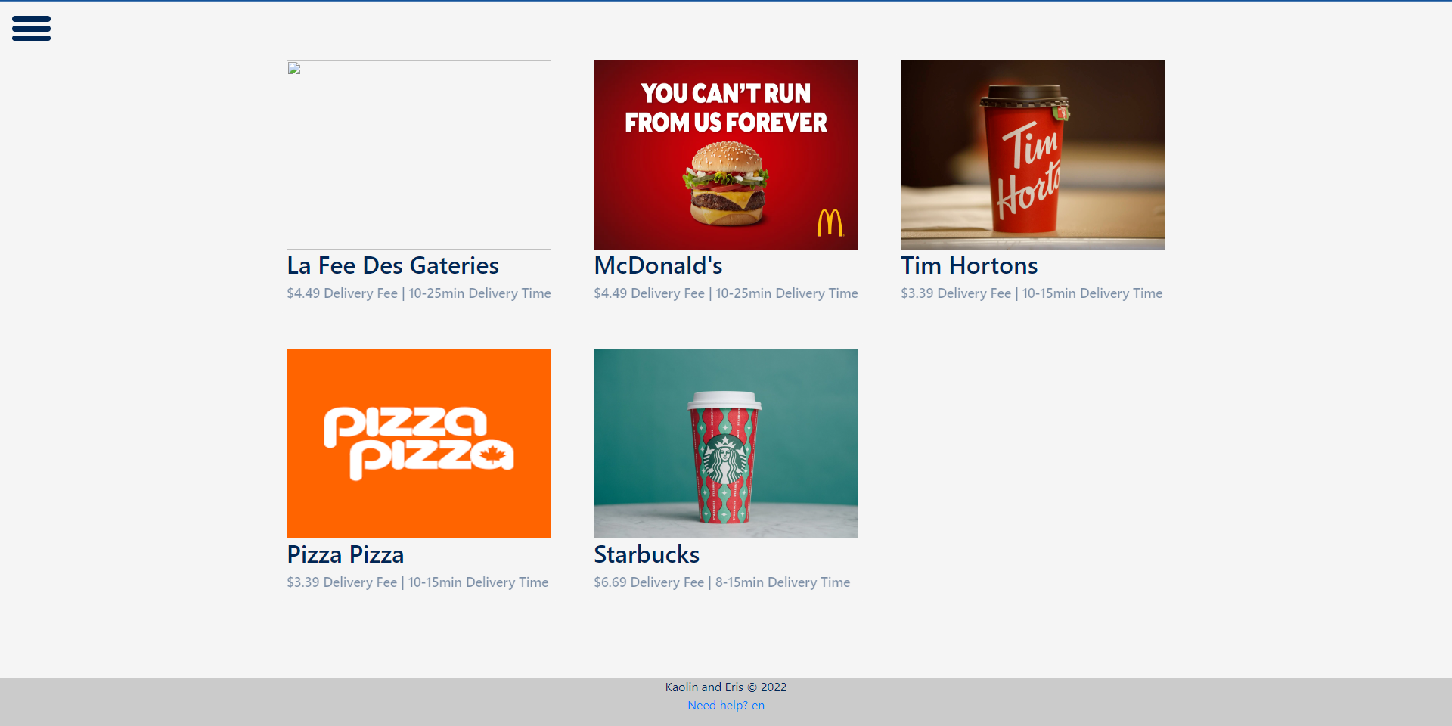

Step 2. Click the hamburger menu on the top left

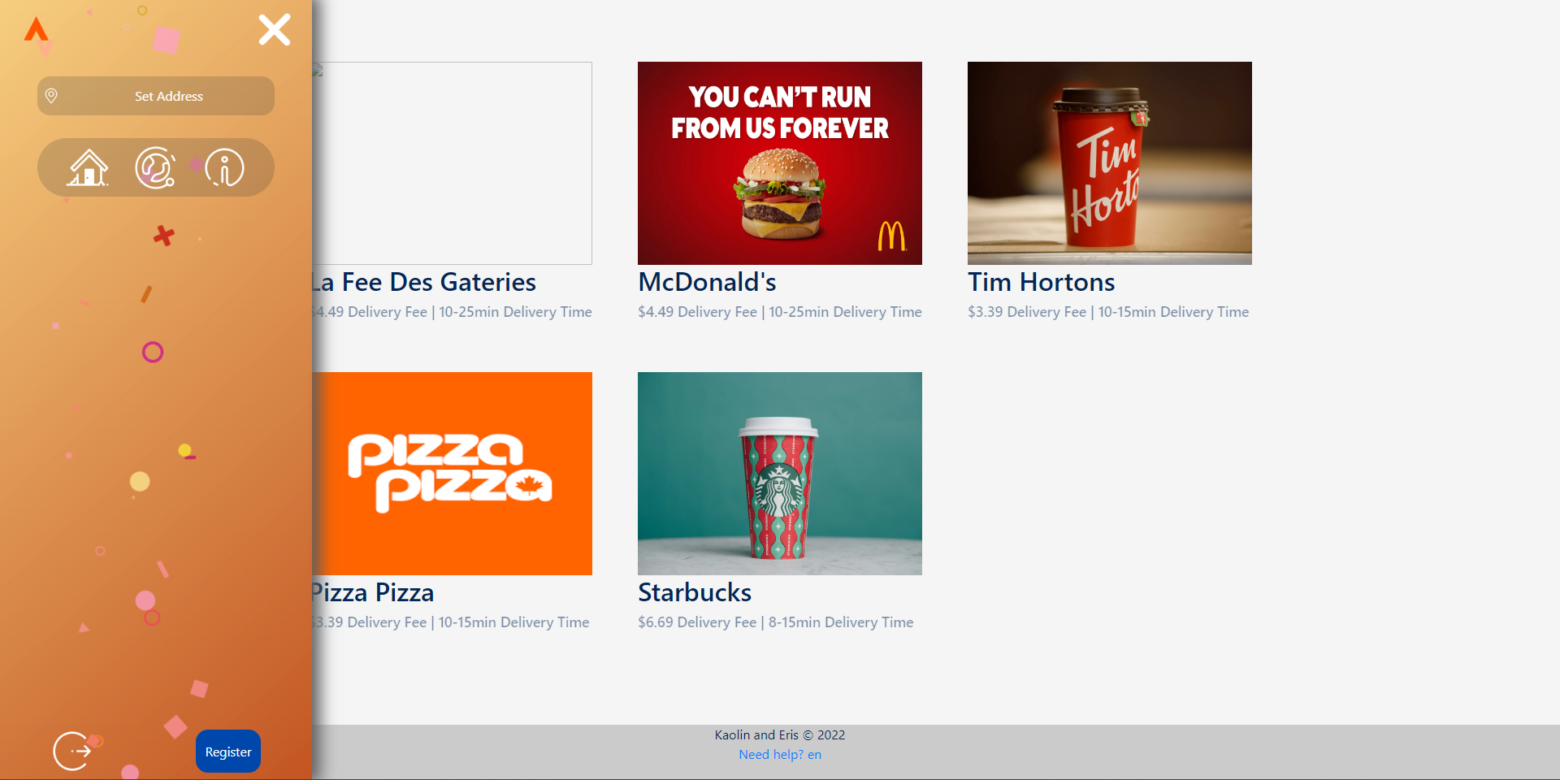

Step 3. Click set address

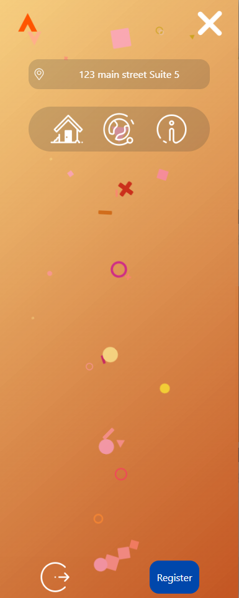

Step 4. Go through with the checkout process as though you were logged in

1. Visit our FAQ page for more information

Step 1. On the home page, click the FAQ button on the top left OR on the explore page, open the hamburger menu and click the information button OR click the Need Help? Button in the footer.

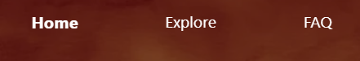

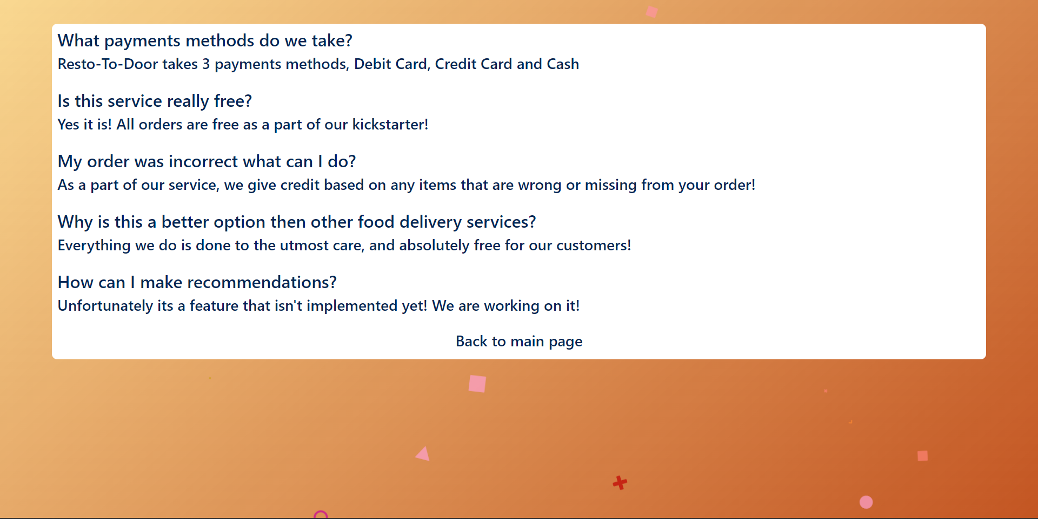

1. Register your own business with the site to sell your own products

Step 1. Go to the home page

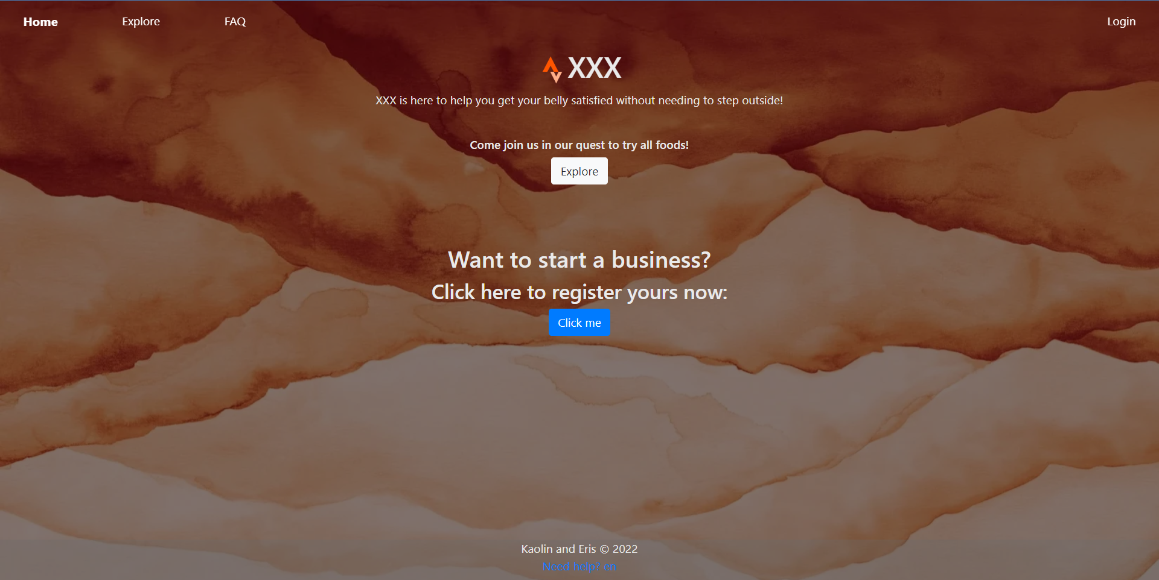

Step 2. Click the button under “Want to start a business?”

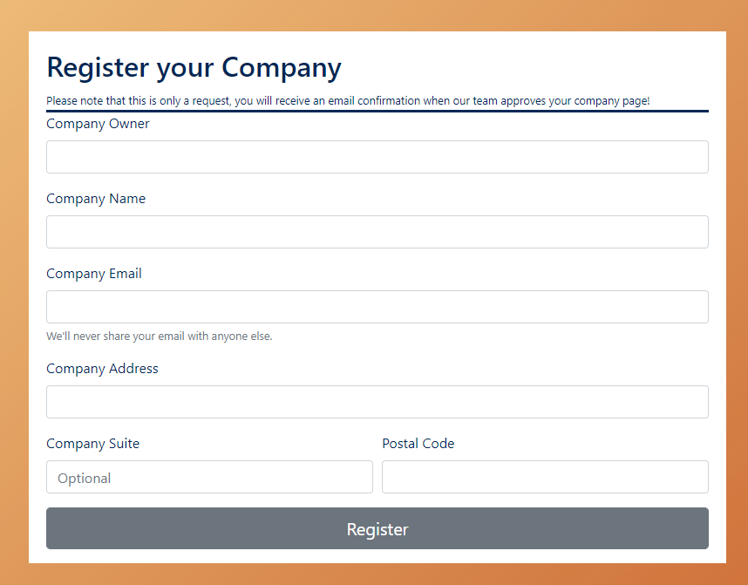

Step 3. Input all information related to the company

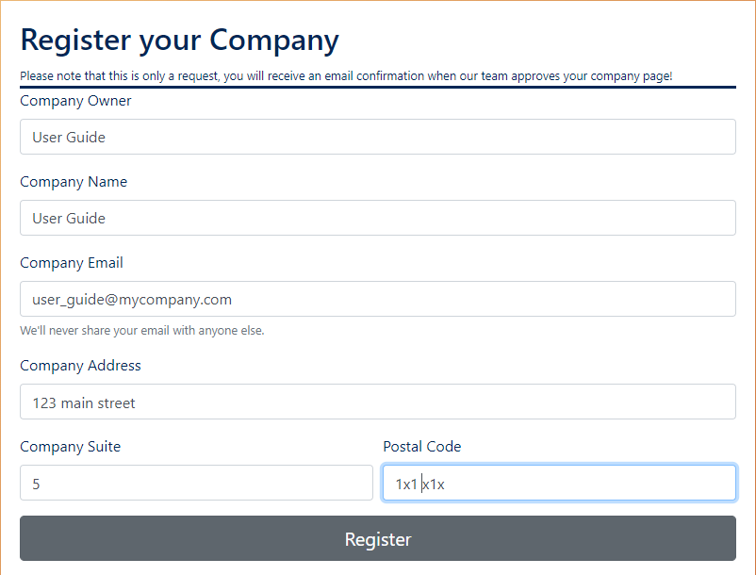

Step 4. Click register

Note that this only sends a request which will need to be accepted by the team for you to be able to continue

1. Change the language

Step 1. Click ‘fr’ or ‘en’ in the footer to switch to the other language



